OSSP Practical 9

Code

Part A: Low-Level File Copy Program

#include <fcntl.h>
#include <unistd.h>
#include <stdio.h>

int main() {
int fd_src = open("source.txt", O_RDONLY);
if (fd_src < 0) {
perror("Source open error");
return 1;
}

int fd_dest = open("dest.txt", O_WRONLY | O_CREAT | O_TRUNC, 0644);
if (fd_dest < 0) {
perror("Destination open error");
close(fd_src);
return 1;
}

char buffer[1024];
ssize_t bytes_read;
while ((bytes_read = read(fd_src, buffer, sizeof(buffer))) > 0) {
write(fd_dest, buffer, bytes_read);
}

close(fd_src);
close(fd_dest);
printf("File copied successfully via low-level system calls.\n");
return 0;
}

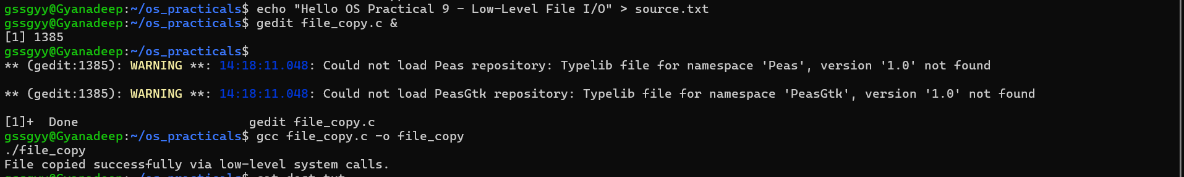

Part B: I/O Redirection Program

#include <stdio.h>
#include <fcntl.h>
#include <unistd.h>

int main() {
int fd = open("output.txt", O_WRONLY | O_CREAT | O_TRUNC, 0644);
if (fd < 0) {
perror("Open error");
return 1;
}

// Redirect stdout (file descriptor 1) to the file descriptor 'fd'
dup2(fd, STDOUT_FILENO);
close(fd);

// This print statement will now go into output.txt instead of your screen
printf("This output is redirected to a file using dup2.\n");

return 0;
}

